

Date: 17-10-2011

Version: 1.1

Obtaining a licence to provide online betting and/or online casino in Denmark
Instructions on the procedure for technical connection

Gambling Control System
2011

Document history:

Version | Date | Description of changes
1.0 | 26.09.2011 | Document published
1.1 | 17.10.2011 | a) End-points to Tamper Token and ROFUS with certificate added to section 3.3.1  b) Reference to document inserted in section 2.3 and description updated.

Table of contents
1. Introduction 4
1.1. The technical connection procedure 4
2. SAFE 6
2.1. Applicant’s communication about access to SAFE 6
2.2. The setting-up of the applicant’s SAFE and the testing of the access to SAFE 6
2.3. The applicant’s preparation of test material for standard records 6
2.4. Spillemyndigheden’s assessment of standard records and documentation 7
3. Tamper Token and ROFUS 8
3.1. The applicant’s access to Tamper Token and ROFUS 8
3.2. Setting-up the applicant for Tamper Token and ROFUS 8
3.3. Applicant testing the Tamper Token and ROFUS 8
3.3.1. End-points for services in the demo environment 9
3.3.2. The applicant’s connectivity test 9
3.4. Spillemyndigheden’s assessment of the test 9
4. Final assessment 11

Introduction

This manual covers the procedure for the technical connection for applicants who want to be approved to provide online betting and/or online casinos in Denmark.

The complete procedure for connection consists of a legal and a technical connection procedure, which are taking place simultaneously. This means that the work related to issuing the license will progress in two tracks independently. Thus it must be emphasized that a successful outcome of the technical procedure not is a guarantee that a license is given. The applicant must therefore consider whether to start working on the technical connection procedure before a legal decision about issuing a license is made.

This document is about the technical connection procedure.

The technical connection procedure

The technical connection procedure consists of two procedures:

- A procedure regarding SAFE
- A procedure regarding Tamper Token and ROFUS

The two procedures will be started at the same time, but for some test cases the two procedures are dependent on each other. The complete process for the technical connection procedure is illustrated in figure 1.

The process regarding SAFE is further described in chapter 2 and the process regarding Tamper Token and ROFUS are further described in chapter 3. The final technical approval is described in chapter Error: Reference source not found.

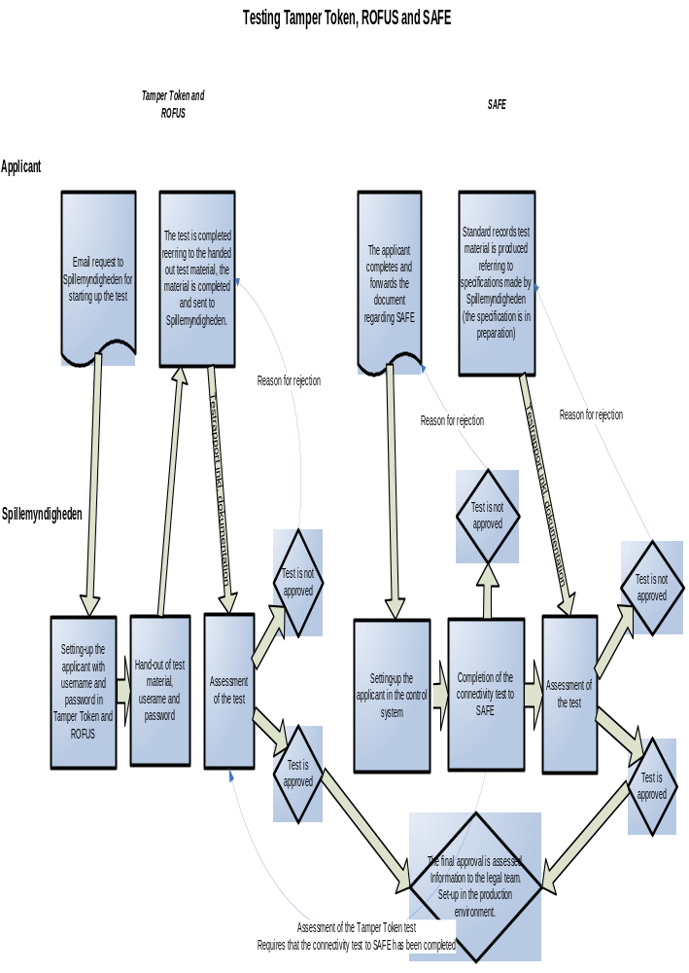

Figure 1: The technical connection procedure

SAFE

Each applicant shall have a file server named SAFE to make standard records accessible to Spillemyndigheden. To complete the technical connection procedure Spillemyndigheden must be able to connect to the applicant’s SAFE and collect data. Besides the test of the possibility of connecting to SAFE, Spillemyndigheden will also complete a verification of the applicant’s interpretation of standard records.

Applicant’s communication about access to SAFE

Spillemyndigheden shall have access to the applicant’s SAFE, which is connected using FTPS. To be able to access SAFE Spillemyndigheden needs some information from the applicant. For this purpose a document for the communication with the applicant has been prepared: ”Skema til ansøgers oplysninger vedr SAFE – dansk.doc”. The document is also available in an English version.

The applicant must fill in the form and forward it to Spillemyndigheden. The document is available at www.spillemyndigheden.dk .

Documents
Skema til ansøgers oplysninger vedr SAFE – dansk.doc
Skema til ansøgers oplysninger vedr SAFE – english.doc

The setting-up of the applicant’s SAFE and the testing of the access to SAFE

Spillemyndigheden will set up the applicant’s SAFE in its own control system and complete a test of access to SAFE. If the test is not completed properly a message with reason for the rejection will be sent to the applicant. After that the applicant can correct the errors and resend the document. Spillemyndigheden will communicate potential errors to the contact person stated in the form.

Start condition | Applicant has sent the document regarding access to SAFE or Appendix B.
End condition | Spillemyndigheden has successfully completed the testing of access to SAFE.

The applicant’s preparation of test material for standard records

Spillemyndigheden must approve the applicant’s interpretation of standard records before a license to provide online betting and online casino can be issued. For this purpose Spillemyndigheden has prepared a separate document with description of the test material for standard records that the applicant must deliver. The document is available on Spillemyndigheden’s website under the link “Test of standard records”. There is a Danish version available on the Danish website and an English version available on the English website.

Documents
See link “Test af standard records” (Danish) or “Test of standard records” (English)

Spillemyndigheden’s assessment of standard records and documentation

Spillemyndigheden will carry out the testing of the applicant’s standard records and evaluate the forwarded documentation. If the applicant’s standard records and documentation are satisfactory, the material is approved. If the standard records and documentation are not satisfactory Spillemyndigheden will inform the applicant with the reason for the rejection. Thereafter the applicant can improve the standard records and documentation, and Spillemyndigheden will again carry out the test and assessment.

Start condition | The applicant has placed the requisite standard records on SAFE zipped with Tamper Token and forwarded further requisite documentation.
End condition | Spillemyndigheden has successfully completed all testing of standard records and it has been considered satisfactory.

Tamper Token and ROFUS

Tamper Token is a security solution which must ensure the integrity of data. The applicant must demonstrate the use of Tamper Token to obtain a license.

ROFUS is the Register of Self excluded Players. On opening a new player account the applicant must verify that the player is not registered in ROFUS and that the player’s social security number exists. On login to account the applicant shall also verify that the player is not registered in ROFUS.

The applicant’s access to Tamper Token and ROFUS

An applicant who wants to access Tamper Token and ROFUS must contact Spillemyndigheden by using tekniske.spm@skat.dk or filling in the form “Appendix B”. The applicant’s name, contact person and email must be stated.

Setting-up the applicant for Tamper Token and ROFUS

After having received the application about access to Tamper Token and ROFUS Spillemyndigheden will set-up the applicant in the system and issue username and password. Spillemyndigheden will send a form to the applicant containing the tests to be run, and social security numbers to be used in the tests.

Applicant testing the Tamper Token and ROFUS

The applicant shall complete the tests as described in the form and report received replies and potential remarks regarding the test. Potential errors are also reported in the form next to the test in which the error occurred. The failing test should be retested to see if the error is general or sporadic. This can be stated in the comment box.

After testing the form is returned to Spillemyndigheden for approval. If any errors occurs during the test, these must be resolved either by the applicant or Spillemyndigheden and a new test must be completed without errors. This procedure is individually arranged between the applicant and Spillemyndigheden.

The test cases are described in the document ”Testcases til ansøger – dansk.xls” which can be found at Spillemyndigheden’s website. An English version is also available. To understand how Tamper Token and ROFUS are working the applicant can try out the test cases in SoapUI or a similar program.

For the applicant to pass the test the applicant must attach documentation for the completion of the test in the applicant’s gaming system (or test environment).

Start condition | The applicant has received username, password and test cases with social security numbers.
End condition | The applicant has completed the tests, registered and forwarded the results in the test case form, attached documentation for the completion of the tests in the applicant’s gaming system and Spillemyndigheden has approved the test results.

Documents
Testcases til ansøger – dansk.xls
Testcases til ansøger – english.xls

End-points for services in the demo environment

Below are the end-points for the services in the demo environment for Tamper Token and ROFUS, which are to be used for the applicant’s test of the two systems. They are web service-based system, which are accessed via the internet. If the applicant completes the technical and the legal connection procedure and obtains a license to provide online betting and online casino in Denmark, Spillemyndigheden will provide the applicant with end-points to the production environment.

Tamper Token services in the DEMO environment:
Without certificate: http://213.174.72.41:7001/TamperTokenAnvend/TamperTokenAnvendService
With certificate: https://213.174.72.41:7002/TamperTokenAnvend/TamperTokenAnvendService

ROFUS services in the DEMO environment:
Without certificate: http://213.174.72.41:7001/GamblerProject/GamblerService
With certificate: https://213.174.72.41:7002/GamblerProject/GamblerService

The applicant’s connectivity test

The applicant can complete the connectivity test as follows:

- End-point is entered in a browser as follows for respectively Tamper Token and ROFUS (similarly if the test should be performed on the end-point without certificate):
  - https://213.174.72.41:7002/TamperTokenAnvend/TamperTokenAnvendService?wsdl
  - https://213.174.72.41:7002/GamblerProject/GamblerService?wsdl
- A login screen is opened in the browser and the applicant enters user name and password received from Spillemyndigheden.
- If the connectivity test is successful the wsdl file can be seen in the browser.

Start condition | The applicant has received username, password and test cases from Spillemyndigheden.
End condition | The applicant can see the wsdl file in the browser.

Spillemyndigheden’s assessment of the test

Spillemyndigheden will assess the applicant’s test based on the completed test form and the forwarded documentation. Furthermore, at this point the applicant must have passed the connectivity test regarding Spillemyndigheden’s access to the applicant’s SAFE before the applicant’s use of Tamper Token can be tested by Spillemyndigheden. If the applicant’s test is assessed to be properly completed with a satisfying result the applicant’s test of Tamper Token and ROFUS will be approved. If it is not assessed to be completed properly or if the result is not satisfying Spillemyndigheden will inform the applicant with the reason for the rejection. After that, the applicant can improve the tests and Spillemyndigheden will complete the test and assessment again.

Final assessment

When all tests completed by the applicant have been approved Spillemyndigheden will make a final assessment. On special occasions Spillemyndigheden will reserve the right to demand further tests. If the applicant is accepted, the legal track is informed that the applicant has completed the technical connection procedure. Furthermore the applicant is set-up in the production environment for Tamper Token and ROFUS and the applicant is informed that the technical connection procedure has been completed.

